Spread Spectrum Systems:

Increasing the bandwidth of the baseband signal as compared to the original signal with help of pseudo-random noise.

Advantages:

1. Security: Because of the pseudo random noise in the signal being transmitted security increases and message becomes difficult to decode, the pseudo random noise is only know to the transmitter. Thus there is estrablishment of secure comminication.
2. Immunity to distortions: The signal being tranmitted already has noise due to use of pseudo random noise and hence noise in the channel wont affect our signal much.
3. Immune to interference/jamming: If bandwith of signal is small then someone can send an interfering signal in that bandwidth for creating interference but in spread spectrrum the bandwidth increases so it becomes difficult to interfere with the signal.
4. We can use any multiple access technique like tdma,fdma or cdma in spread spectrum systems.
5. Prevention of detection and to limit power flux density.

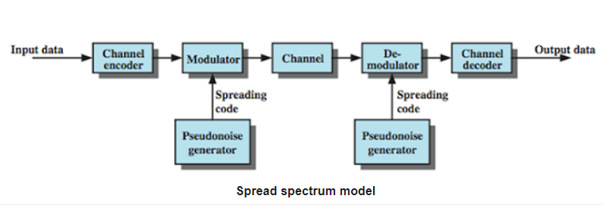

Pseudo random noise is deterministic (same being used at both modulator and demodulator and periodic in nature.

